SIMATS ENGINEERING (SAVEETHA SCHOOL OF ENGINEERING)
Department of Computer Science and Engineering
CO4 ASSESSMENT TOOL 2 – CI/CD Pipeline Design Exercise

Course Code: | CSA10 / CSA1063 | Course Title: | Software Engineering
CO Assessed: | CO4 | Assessment: | Assessment Tool 2 – CI/CD Pipeline Design Exercise
Weightage: | 20% | Total Marks: | 25
CO4 Statement: | Implement robust testing, quality assurance, and DevOps practices, emphasizing security, reliability, and ethics
Student Name: | Keerthana.G | Reg. No.: | 192521446
Date: |  | Duration: | 60 minutes

Code of Conduct
I __________________________ (Name / Reg No) certify that this submission is my original work and that I have adhered to the guidelines specified for this assessment. I understand that any violation of academic integrity rules will result in disciplinary action.
Signature of the Student: _________________________

Evaluation Criteria | Excellent (4 Marks) | Good (3 Marks) | Satisfactory (2 Marks) | Needs Improvement (1 Mark)
Requirement & Pipeline Analysis(15%) | Clearly analyzes the assigned problem and identifies comprehensive CI/CD requirements | Identifies most relevant requirements | Identifies basic requirements with some gaps | Requirements are unclear or incomplete
Pipeline Architecture & Workflow(25%) | Designs a complete, logical pipeline covering source, build, test, quality check, package, and deployment stages | Pipeline covers most major stages with minor gaps | Basic pipeline is designed but several stages are missing | Pipeline is incomplete or poorly structured
Tools & Technology Selection(20%) | Selects appropriate tools for each stage and provides clear justification | Appropriate tools selected with reasonable justification | Tools are identified but justification is limited | Tools are inappropriate or not clearly identified
Automated Testing & Quality Integration(15%) | Effectively integrates automated testing and code-quality/security checks into the pipeline | Includes major testing and quality checks | Includes basic testing with limited integration | Testing/quality checks are missing or inappropriate
Deployment, Security & Rollback Strategy(15%) | Clearly designs deployment environments, security practices, monitoring, and rollback strategy | Covers deployment and most security/rollback aspects | Basic deployment strategy with limited security/rollback details | Deployment strategy is incomplete or lacks security considerations
Pipeline Diagram & Documentation(10%) | Clear, accurate, professional diagram with excellent explanation and documentation | Well-presented diagram and documentation with minor issues | Adequate diagram/documentation but lacks clarity | Poorly presented, incomplete, or difficult to understand

Annexure A – CI/CD Pipeline Design Exercise
AN AI-DRIVEN HOTEL RESERVATION AND ROOM MANAGEMENT PLATFORM WITH DYNAMIC PRICING AND DEMAND FORECASTING
The exercise should include:
- Analyze the project requirements and identify the CI/CD needs of the assigned problem statement.
Project Requirements
- User registration and secure login.
- Search and check hotel room availability.
- Online room booking, cancellation, and modification.
- Manage rooms, customers, and reservations.
- Process online payments securely.
- Generate reports for hotel administrators.
- Use AI/ML for demand forecasting.
- Dynamically adjust room prices based on demand, season, occupancy, and booking trends.
- Provide a reliable, secure, scalable, and user-friendly platform.
CI/CD Needs
- Continuous Integration: Automatically build and integrate code whenever developers commit changes.
- Automated Testing: Run unit, integration, API, and AI/ML model tests automatically.
- Code Quality: Analyze code for bugs, code smells, and maintainability issues.
- Security Checks: Scan dependencies and code for vulnerabilities and protect sensitive hotel/customer data.
- AI/ML Validation: Check the accuracy and performance of demand forecasting models before deployment.
- Automated Deployment: Deploy successfully tested versions to development, staging, and production environments.
- Monitoring: Continuously monitor application performance, booking services, and system health.
- Rollback: Automatically or manually restore the previous stable version if a deployment fails.
- Notifications: Notify developers about build failures, test results, security issues, and deployment status.

- Design the CI/CD pipeline workflow showing stages such as source code management, build, testing, code quality analysis, packaging, and deployment.
CI/CD Pipeline Workflow
Developer → Source Code Management → Build → Testing → Code Quality & Security → Packaging → Staging → Production → Monitoring
Pipeline Stages
- Source Code Management
  - Developers write and update application and AI/ML code.
  - Code is stored and version-controlled using Git and GitHub.
  - A pipeline is triggered whenever code is pushed or a pull request is created.
- Build
  - Application dependencies are installed.
  - Backend, frontend, and AI/ML components are built.
  - Build errors are automatically detected.
- Testing
  - Unit testing checks individual functions.
  - Integration testing checks database, APIs, and application modules.
  - API testing verifies reservation, login, room availability, and pricing services.
  - AI/ML testing checks demand forecasting model performance.
- Code Quality and Security Analysis
  - SonarQube checks code quality, bugs, and code smells.
  - Security scanning identifies vulnerable dependencies and insecure code.
  - The pipeline stops if critical quality or security checks fail.
- Packaging
  - The successfully tested application is packaged into a Docker container.
  - The Docker image is stored in a container registry such as Docker Hub or GitHub Container Registry.
- Staging Deployment
  - The Docker image is deployed to the staging environment.
  - Final integration, performance, security, and user acceptance tests are performed.
- Production Deployment
  - After successful staging validation and approval, the application is deployed to the production environment.
  - A controlled deployment strategy such as Blue-Green Deployment can be used.
- Monitoring and Rollback
  - The production system is monitored for errors, performance, and availability.
  - If a serious problem occurs, the system rolls back to the previous stable version.
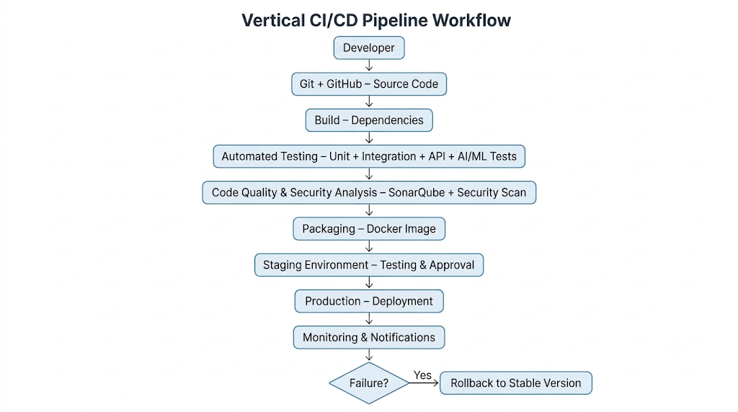

- Identify suitable tools and technologies for each stage of the pipeline and justify their selection.
Source Code Management – Git & GitHub
  - Used to store and manage project source code.
  - Provides version control, branching, and collaboration.
CI/CD Automation – GitHub Actions
  - Automates the complete CI/CD pipeline.
  - Automatically triggers builds and tests whenever code is updated.
Build – Maven / npm / pip
  - Used to install dependencies and build the application.
  - Helps identify build and dependency errors early.
Testing – JUnit / PyTest / Jest
  - Used for automated unit testing.
  - Ensures individual modules and functions work correctly.
Integration & API Testing – Postman / Newman
  - Tests communication between application modules and APIs.
  - Useful for testing login, room booking, availability, payment, and pricing APIs.
AI/ML Testing – PyTest / Scikit-learn
  - Used to test the demand forecasting model.
  - Checks prediction accuracy and model performance.
Code Quality Analysis – SonarQube
  - Detects bugs, code smells, duplication, and maintainability issues.
  - Improves overall code quality.
Security Scanning – OWASP Dependency-Check
  - Identifies vulnerabilities in third-party libraries and dependencies.
  - Helps improve application security.
Packaging – Docker
  - Packages the application and its dependencies into containers.
  - Ensures consistent execution across different environments.
Container Registry – Docker Hub / GitHub Container Registry
  - Stores and manages Docker images.
  - Makes application images available for deployment.
Deployment – Kubernetes
  - Deploys and manages containers in staging and production.
  - Supports scalability, availability, and automatic recovery.
Monitoring – Prometheus & Grafana
  - Monitors application performance and system health.
  - Provides dashboards and alerts for failures.
Notifications – Email / Slack / Microsoft Teams
  - Sends notifications about build, test, security, and deployment results.
  - Helps the development team respond quickly to failures.
Rollback – Kubernetes / Docker
  - Restores the previous stable version when deployment fails.
  - Reduces downtime and maintains system reliability.

- Define appropriate automated testing strategies to be integrated into the pipeline.
• Unit Testing
- Test individual functions and modules separately.
- Example: Login validation, room availability, booking calculation, and price calculation.
- Tools: JUnit / PyTest / Jest.
• Integration Testing
- Verify communication between different system components.
- Test backend, database, reservation system, payment service, and AI/ML module.
• API Testing
- Test REST APIs automatically.
- Verify login, room search, room booking, cancellation, payment, and dynamic pricing APIs.
- Tools: Postman / Newman.
• AI/ML Model Testing
- Test the demand forecasting model for accuracy and consistency.
- Check performance using MAE, RMSE, and prediction accuracy.
- Ensure the model meets the minimum accuracy threshold before deployment.
• Database Testing
- Verify correct storage and retrieval of users, rooms, bookings, and payment records.
- Check database integrity and transaction consistency.
• Security Testing
- Scan the application and dependencies for vulnerabilities.
- Test authentication, authorization, password protection, and API security.
- Tools: OWASP Dependency-Check / OWASP ZAP.
• Performance Testing
- Test the system under high numbers of users and booking requests.
- Verify response time during peak hotel booking periods.
- Tools: JMeter / Gatling.
• Regression Testing
- Automatically rerun existing tests whenever new features or changes are introduced.
- Ensures new updates do not break existing booking and room management functions.
• Smoke Testing
- Perform basic tests after deployment to verify that the application is running correctly.
- Check login, room search, booking, and main APIs.
• End-to-End Testing
- Test the complete customer workflow from login → room search → booking → payment → confirmation.
- Ensures all components work together correctly.

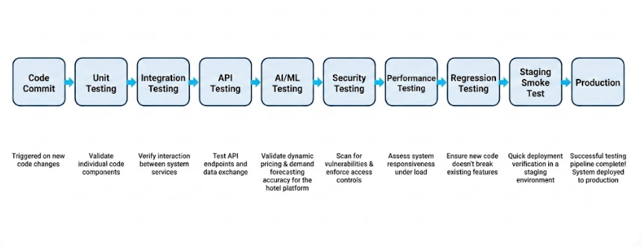

- Design the deployment strategy, including development, testing/staging, and production environments.
Development Environment
- Used by developers to develop new features and fix bugs.
- Code changes are frequently pushed to GitHub.
- CI pipeline automatically builds and performs basic tests.
- Developers verify features such as room booking, availability, and dynamic pricing.
- Unstable changes are restricted to the development environment.
2. Testing / Staging Environment
- Contains a configuration similar to the production environment.
- Successfully tested code from development is deployed automatically.
- Performs:
  - Integration testing
  - API testing
  - Security testing
  - Performance testing
  - AI/ML model validation
  - User acceptance testing
- Only builds that pass all quality checks are promoted to production.
3. Production Environment
- Contains the live hotel reservation system used by customers and hotel administrators.
- Deployment occurs only after successful staging validation and approval.
- Uses Docker and Kubernetes for reliable deployment and scalability.
- Continuous monitoring is performed using Prometheus and Grafana.
- If a serious deployment failure occurs, the system is rolled back to the previous stable version.
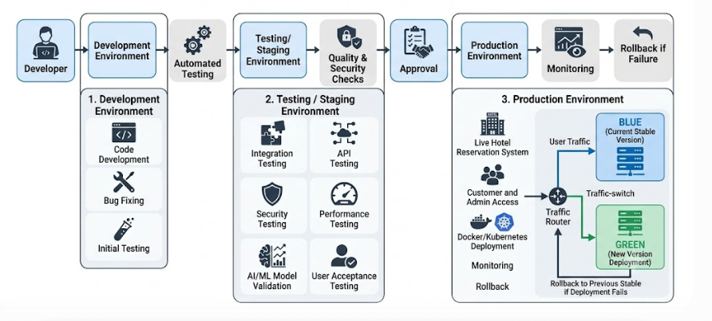
- Incorporate appropriate security, quality checks, notifications, and rollback mechanisms in the pipeline.
Security Checks
- Use OWASP Dependency-Check to identify vulnerable dependencies.
- Use SonarQube to detect security issues and code vulnerabilities.
- Store passwords, API keys, and database credentials using GitHub Secrets.
- Use HTTPS/TLS to protect customer and payment data.
- Implement authentication and role-based access control for customers and administrators.
- Perform automated security testing before production deployment.
Quality Checks
- Perform unit, integration, API, and regression testing.
- Validate the AI/ML demand forecasting model using accuracy metrics such as MAE and RMSE.
- Use SonarQube for code quality, bugs, code smells, and duplication.
- Perform performance testing to ensure the system can handle high booking traffic.
- Use quality gates to prevent deployment when critical tests or quality checks fail.

Notifications
- Send automated notifications when:
  - Build succeeds or fails.
  - Tests pass or fail.
  - Security vulnerabilities are detected.
  - Staging deployment is completed.
  - Production deployment succeeds or fails.
- Notifications can be sent through Email, Slack, or Microsoft Teams.
- This allows developers to respond quickly to pipeline failures.
Rollback Mechanism
- Maintain the previous stable version of the application.
- Use Docker image versioning to store previous releases.
- Use Kubernetes rollback to restore the previous version.
- If health checks or monitoring detect serious errors, production traffic can be switched back to the stable version.
- Blue-Green Deployment can be used to make rollback faster and reduce downtime.
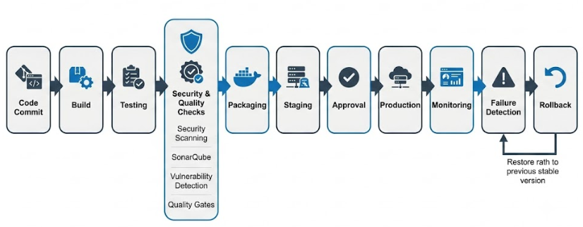

- Prepare a CI/CD pipeline diagram and explain the workflow from code commit to deployment.
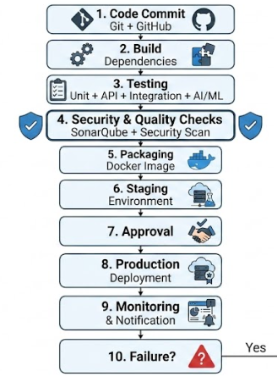

Workflow Explanation
- Code Commit
  - Developers commit application and AI/ML code to GitHub.
  - The CI/CD pipeline is automatically triggered.
- Build
  - Dependencies are installed and the application is built.
  - Build errors are detected before testing.
- Testing
  - Automated unit, integration, API, regression, and AI/ML tests are executed.
  - The pipeline stops if critical tests fail.
- Security & Quality Checks
  - SonarQube checks code quality.
  - Security tools scan for vulnerabilities and insecure dependencies.
  - Only code that passes the quality gates continues.
- Packaging
  - The application is packaged into a Docker image.
  - The image is stored in a container registry.
- Staging
  - The Docker image is deployed to the staging environment.
  - Final testing and validation are performed in an environment similar to production.
- Approval
  - After successful staging validation, the release is approved for production.
- Production Deployment
  - The approved version is deployed to the live hotel reservation platform.
  - Customers and hotel administrators can access the updated system.
- Monitoring & Notification
  - The application is continuously monitored for performance, errors, and availability.
  - Developers receive notifications about deployment status and failures.
- Rollback
- If a serious production failure is detected, the system automatically or manually returns to the previous stable version.
- This minimizes downtime and protects the reliability of the hotel reservation system.
Overall Workflow
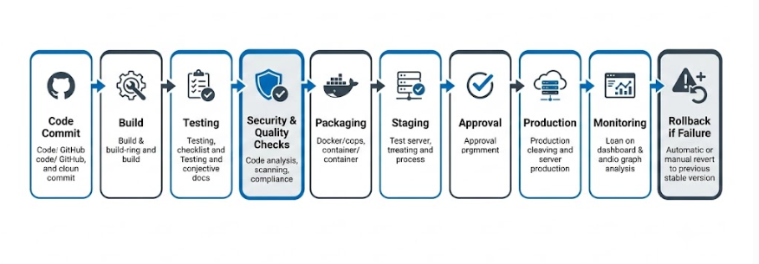
Deliverable: Submit a CI/CD Pipeline Design document containing the pipeline architecture/diagram, stages, tools, configuration/workflow, testing strategy, deployment process, and justification based on the assigned problem statement.

Rubrics for Calculation
Evaluation Criteria | Excellent (4 Marks) | Good (3 Marks) | Satisfactory (2 Marks) | Needs Improvement (1 Mark)
Requirement & Pipeline Analysis(15%) | Clearly analyzes the assigned problem and identifies comprehensive CI/CD requirements | Identifies most relevant requirements | Identifies basic requirements with some gaps | Requirements are unclear or incomplete
Pipeline Architecture & Workflow(25%) | Designs a complete, logical pipeline covering source, build, test, quality check, package, and deployment stages | Pipeline covers most major stages with minor gaps | Basic pipeline is designed but several stages are missing | Pipeline is incomplete or poorly structured
Tools & Technology Selection(20%) | Selects appropriate tools for each stage and provides clear justification | Appropriate tools selected with reasonable justification | Tools are identified but justification is limited | Tools are inappropriate or not clearly identified
Automated Testing & Quality Integration(15%) | Effectively integrates automated testing and code-quality/security checks into the pipeline | Includes major testing and quality checks | Includes basic testing with limited integration | Testing/quality checks are missing or inappropriate
Deployment, Security & Rollback Strategy(15%) | Clearly designs deployment environments, security practices, monitoring, and rollback strategy | Covers deployment and most security/rollback aspects | Basic deployment strategy with limited security/rollback details | Deployment strategy is incomplete or lacks security considerations
Pipeline Diagram & Documentation(10%) | Clear, accurate, professional diagram with excellent explanation and documentation | Well-presented diagram and documentation with minor issues | Adequate diagram/documentation but lacks clarity | Poorly presented, incomplete, or difficult to understand

Criteria | Mark
Requirement & Pipeline Analysis(15%) | /5
Pipeline Architecture & Workflow(25%) | /4
Tools & Technology Selection(20%) | /4
Automated Testing & Quality Integration(15%) | /4
Deployment, Security & Rollback Strategy(15%) | /4
Pipeline Diagram & Documentation(10%) | /4
TOTAL | /25

